

Configuring TF series sensor using TTL to UAVCAN Converter using CUAV_V5 (Px4 Firmware)



Introduction
This document provides first-time testers with instructions on how to test the UAVCAN converter using CUAV_V5 with Px4 Firmware.
Applicable product model of this document ：TFLuna\TFmini-S\TFmini-Plus\TF02-Pro
Applicable communication interface : TTL
The products covered by the test : TFmini-S

Test Preparation
Preparing Tools | Number
PC with windows system | 1
4pin dubond wires | 2
TFmini-S-TTL | 1
CUAV_V5 | 1
QGroundControl
Px4 Firmware | px4_fmu-v5_default.px4
TTL to UAVCAN Converter | 1

Px4 Firmware Burning
To upgrade firmware using QGC ground station, go to Vehicle Setup -> Firmware page of QGC
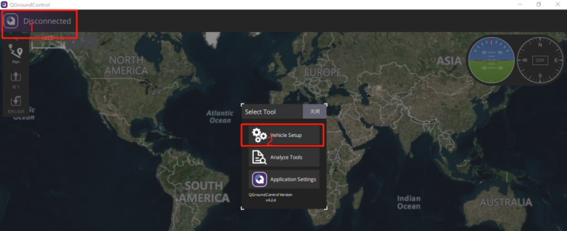
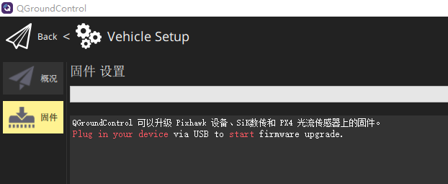
Use USB to connect to the CUAV_V5, select ‘PX4Pro’ in the pop-up firmware Settings, check ‘Advanced Settings’, and select ‘Custom firmware’.
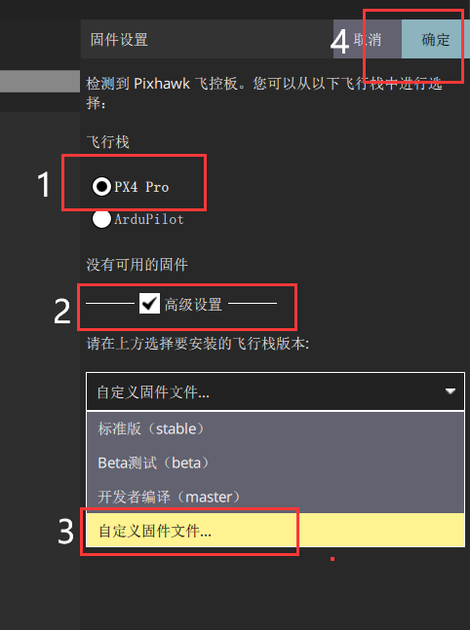
After loading our test firmware’px4_fmu-v5_default.px4’, we enter the upgrade process.
Wait for the upgrade progress bar to complete.
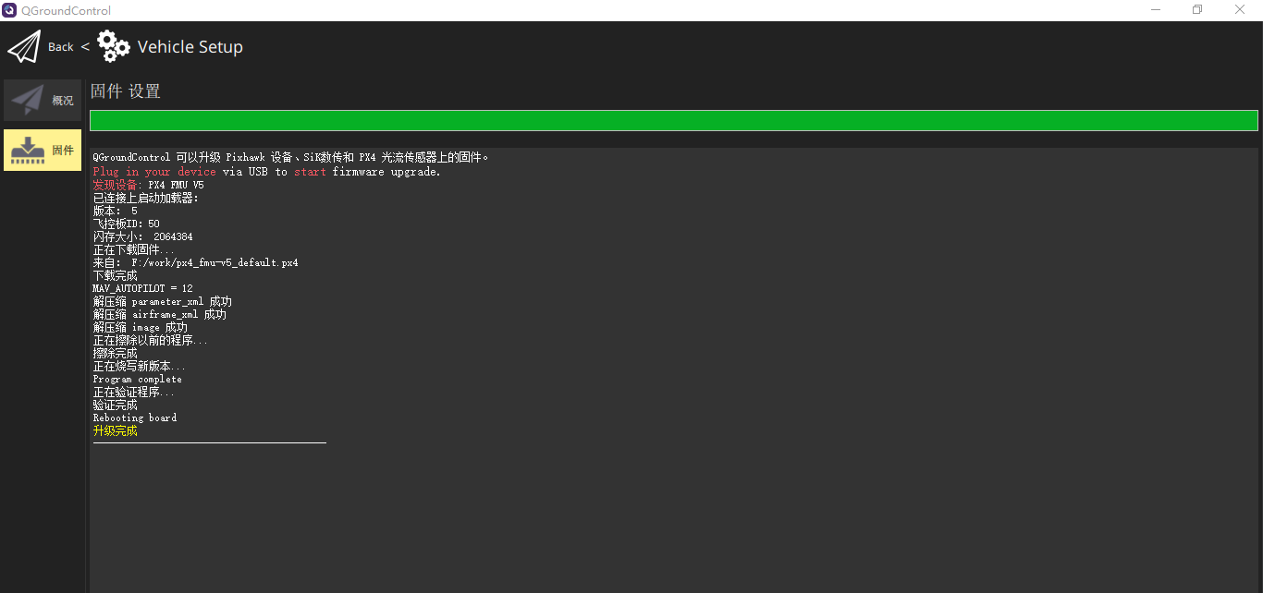

Hardware Configuration
CUAV_V5 is connected to the TTL to UAVCAN converter board, LiDAR and computer (note that the LiDAR ID matches the ID set by the computer),as shown in the figure below:
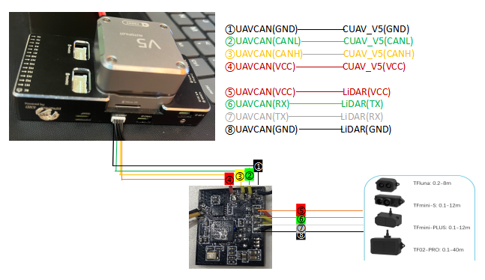
（schematic diagram）

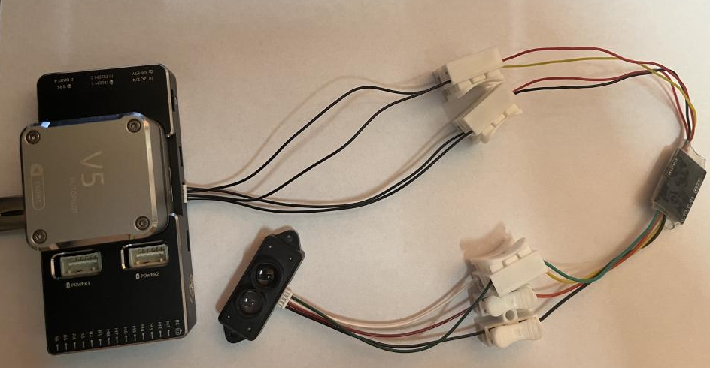
（Connection Example - for reference only）

Parameters Settings
Go to the Parameters page in the Settings and enter the keyword ‘UAVCAN’ in the search box to find ‘UAVCAN_ENABLE’, and change it to ‘Sensors Automatic Config’,as shown below:
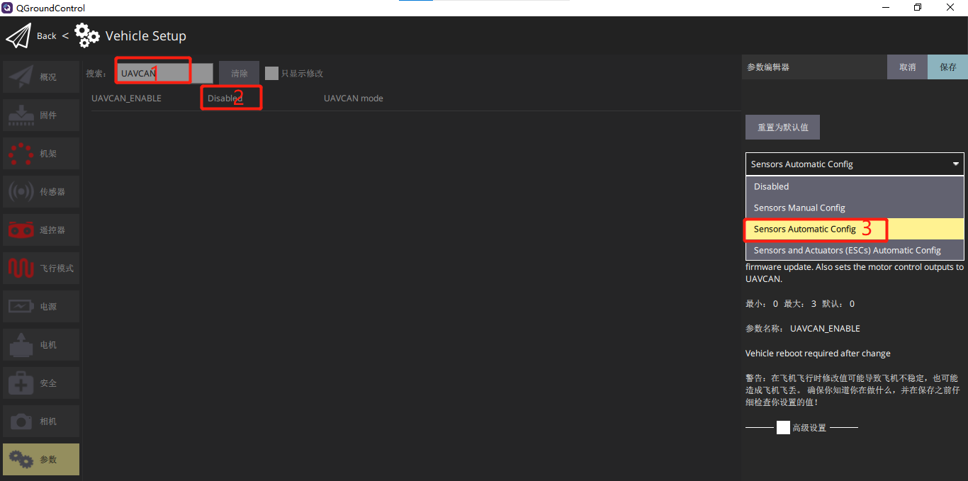
After restarting the device, you can see what is shown in the following figure, and then you should find the ‘UAVCAN_SUB_RNG’ parameter and change it to ‘ENABLE’.
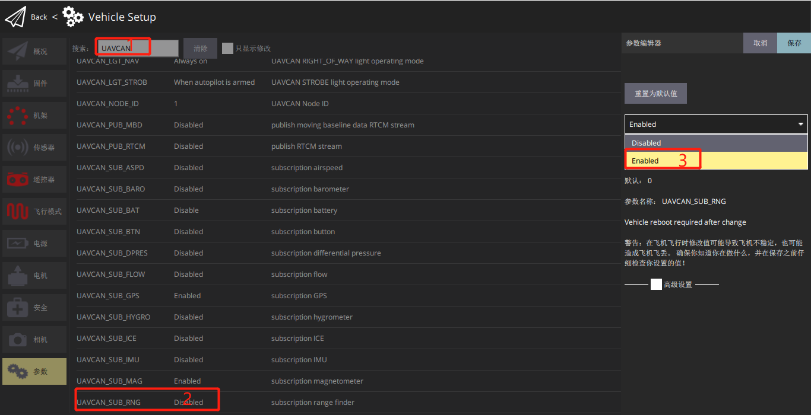
Restart your device again and you will see something like this:
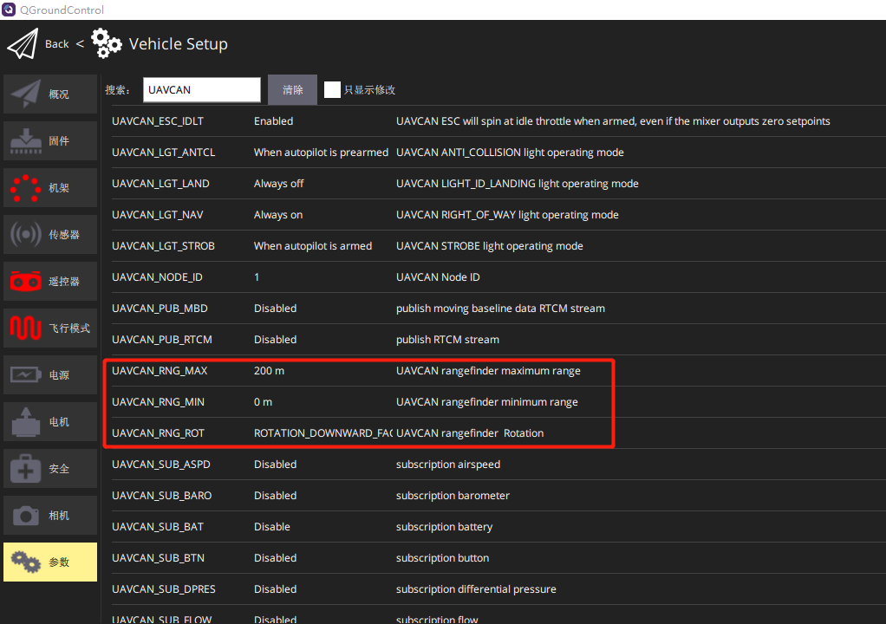
The parameters are described as follows:
UAVCAN_RNG_MAX //The maximum ranging setting for the device
UAVCAN_RNG_MIN //The minimum ranging setting for the device
UAVCAN_RNG_ROT //Setting sensor orientation
Here,the direction is forward (obstacle avoidance), as shown below:(if the direction is downward ,it is altitude hold.)
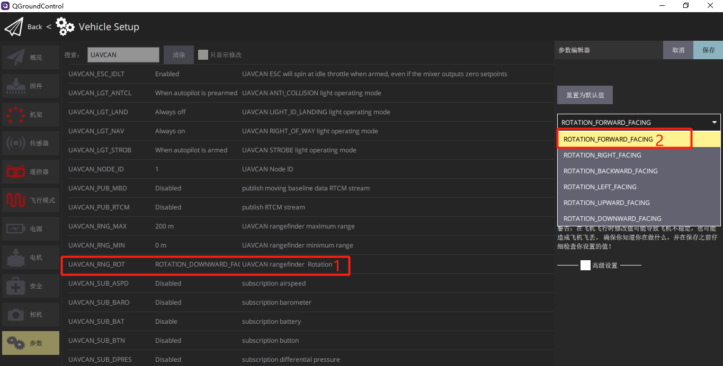
After restarting the device, the ranging value can be seen on the flight interface.

Data Test
Edit the data sheet below the QGC flight interface and add the range display value.
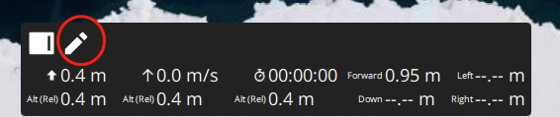
Click the pen flag to enter the edit mode, and click the value to modify the display content and modify the display of the ranging direction value.
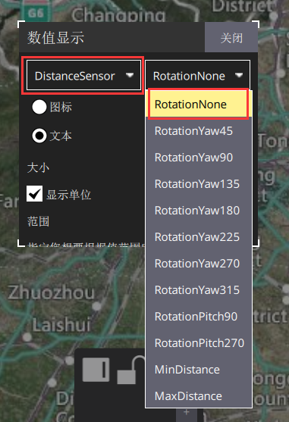
After modification, the display effect is as follows:
