

Configuring TF02-pro with TTL interface using Pixhawk (Px4 Firmware)



Introduction
This document provides first-time testers with instructions on how to test TF02-pro using Pixhawk (Px4 Firmware).
Applicable product model of this document ：TF02-pro-TTL(Confirm the hardware version and firmware version of the product before testing.)

Test Preparation
Preparing Tools | Number
PC with windows system | 1
4pin dubond wires | 1
TF02-pro-TTL | 1
Pixhawk（PX4 ） | 1
QGroundControl
Px4 Firmware | px4_fmu-v3_main1.13.px4

Px4 Firmware Burning
To upgrade firmware using QGC ground station, go to Vehicle Setup -> Firmware page of QGC
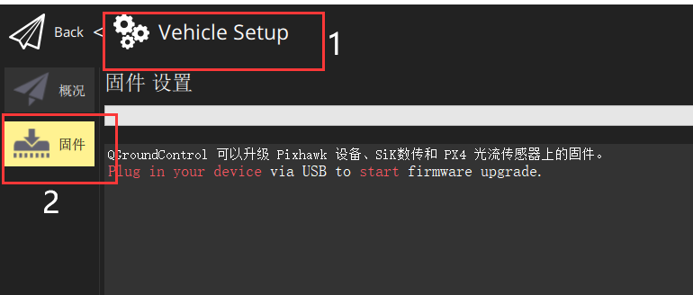
Use USB to connect to the flight control, select ‘PX4Pro’ in the pop-up firmware Settings, check ‘Advanced Settings’, and select ‘Custom firmware’.
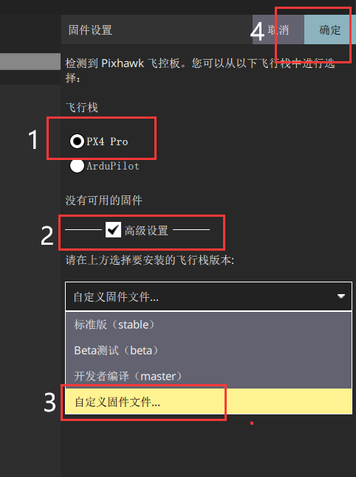
After loading our test firmware’px4_fmu-v3_main1.13.px4’, we enter the upgrade process.
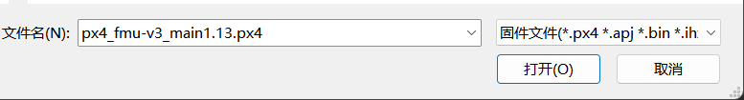
Wait for the upgrade progress bar to complete.
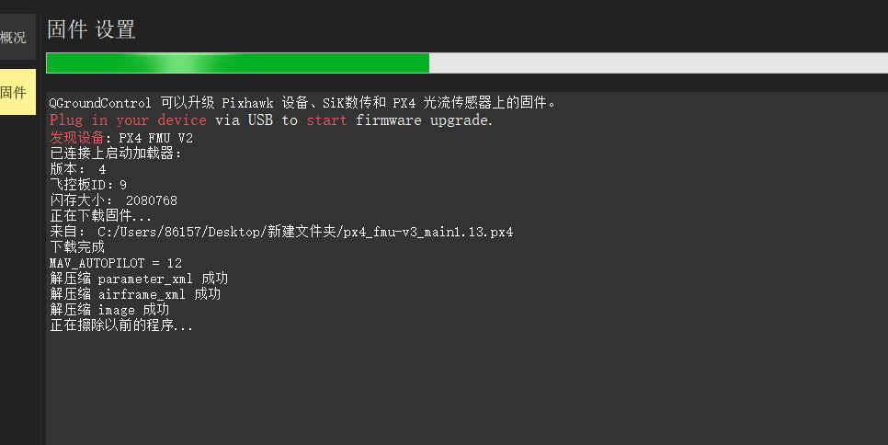

Hardware Configuration
The Pixhawk is connected to the LiDAR and the computer (note that the LiDAR ID matches the ID set by the computer), as shown below:
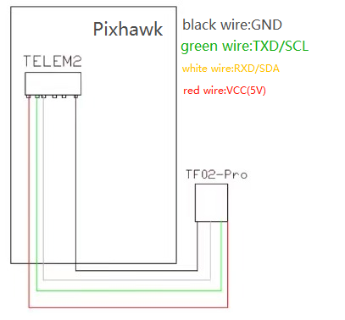
（schematic diagram）
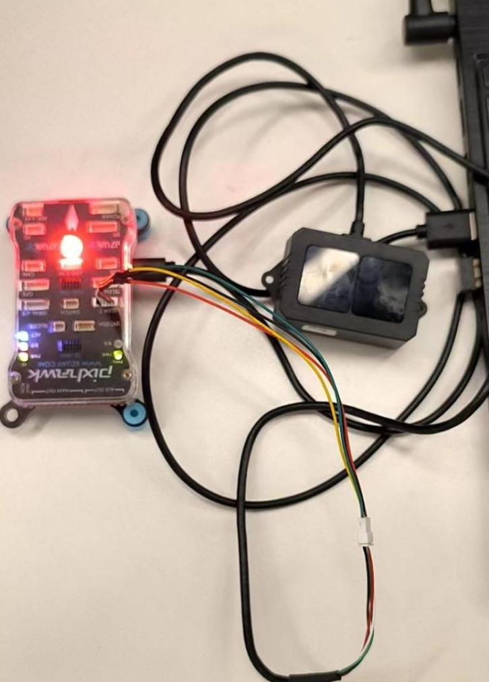
（Connection Example - for reference only）

Parameters Settings
Go to the Parameters page in the Settings and enter the keyword TF in the search box to find it easily, and find SENS_TFMINI_CFG to select a flight control serial port, as shown below
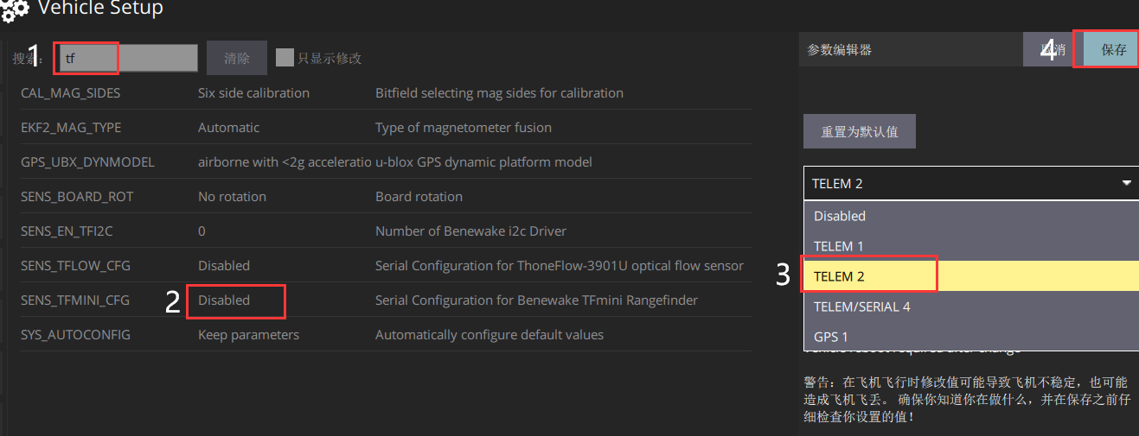
After restarting your device, you should see something like the following:
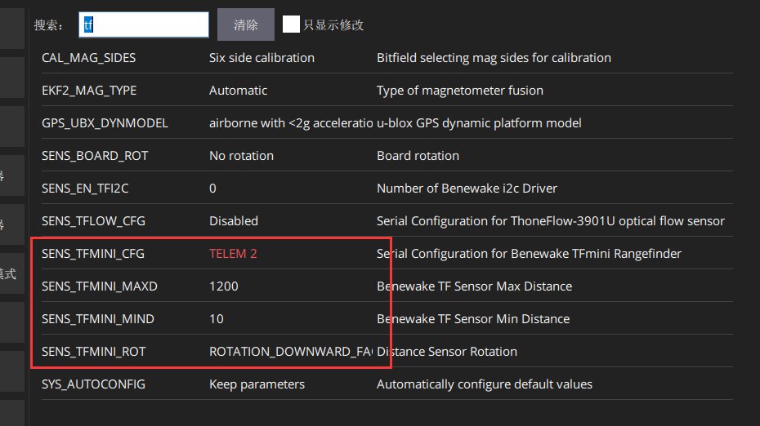
The parameters are described as follows:
SENS_TFMINI_CFG //Select a flight control serial port
SENS_TFMINNI_MAXD //The maximum ranging setting for the x-th TF device in cm
SENS_TFMINNI_MIND //The minimum ranging setting for the x-th TF device in cm
ENS_TFMINI_ROT //Set sensor orientation
Here, the serial port is set to TELEM2, the maximum distance is 4000cm, the minimum distance is 10cm, and the direction is forward, as shown below:
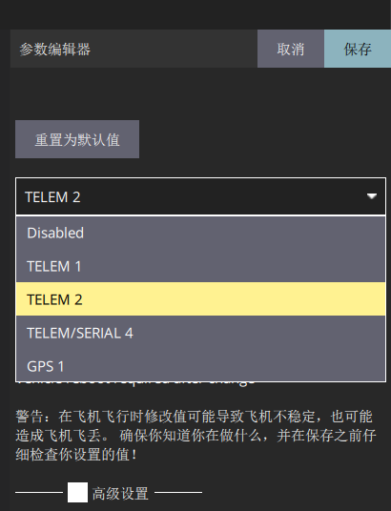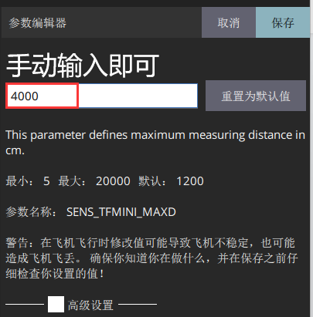
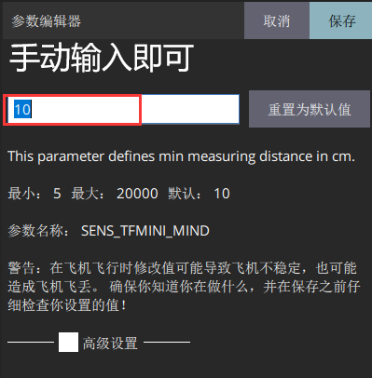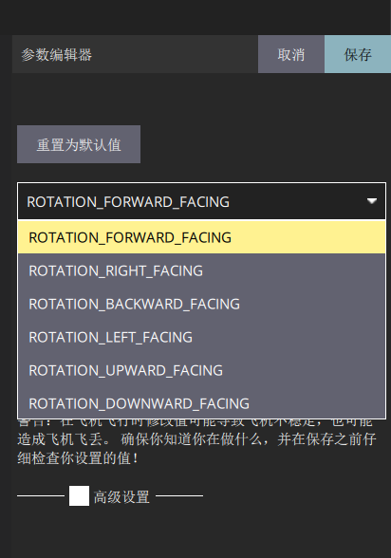
After restarting the device, the ranging value can be seen on the flight interface.

Data Test
Edit the data sheet below the QGC flight interface and add the range display value
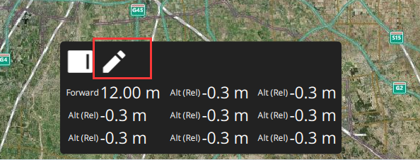
Click the pen flag to enter the edit mode, and click the value to modify the display content and modify the display of the ranging direction value.
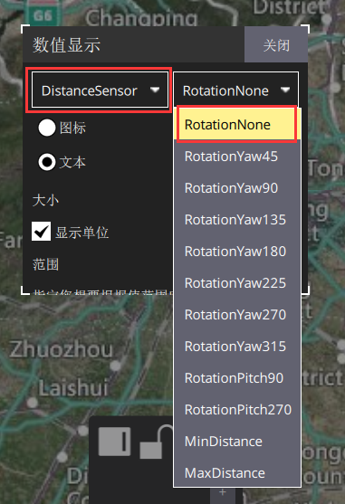
After modification, the display effect is as follows
