

Configuring RDS02UF with TTL interface using CUAV_V5 (Px4 Firmware)



Introduction
This document provides first-time testers with instructions on how to test the RDS02UF using CUAV_V5 with Px4 Firmware.
Applicable product model of this document ：RDS02UF
Applicable communication interface : TTL
The products covered by the test : RDS02UF

Test Preparation
Preparing Tools | Number
PC with windows system | 1
4pin dubond wires | 1
RDS02UF-TTL | 1
CUAV_V5 | 1
QGroundControl
Px4 Firmware | px4_fmu-v5_default.px4
DC POWER SUPPLY | 1

Px4 Firmware Burning
To upgrade firmware using QGC ground station, go to Vehicle Setup -> Firmware page of QGC
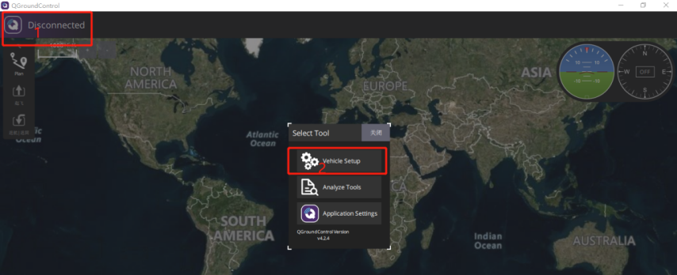
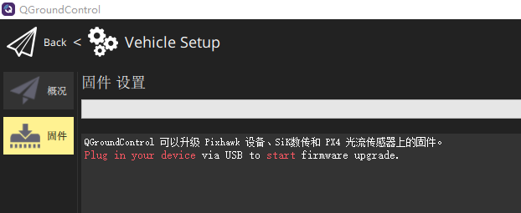
Use USB to connect to the CUAV_V5, select ‘PX4Pro’ in the pop-up firmware Settings, check ‘Advanced Settings’, and select ‘Custom firmware’.
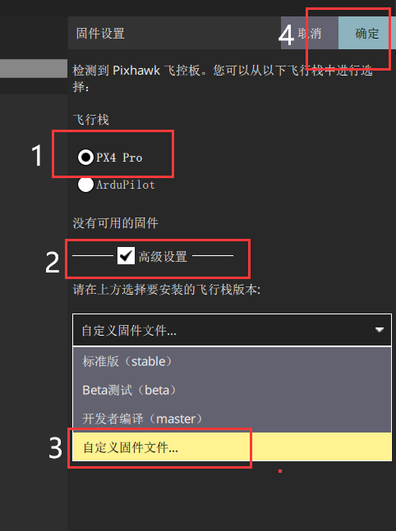
After loading our test firmware’px4_fmu-v5_default.px4’, we enter the upgrade process.
Wait for the upgrade progress bar to complete.
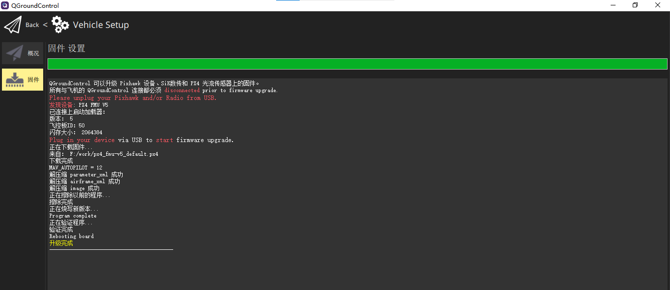

Hardware Configuration
CUAV_V5 is connected to Millimeter Wave Radar and computer (note that the Millimeter Wave Radar ID matches the ID set by the computer), and connected to the power supply, as shown in the following figure:
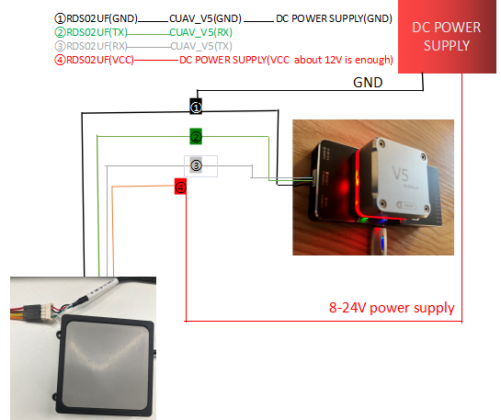
(schematic diagram)
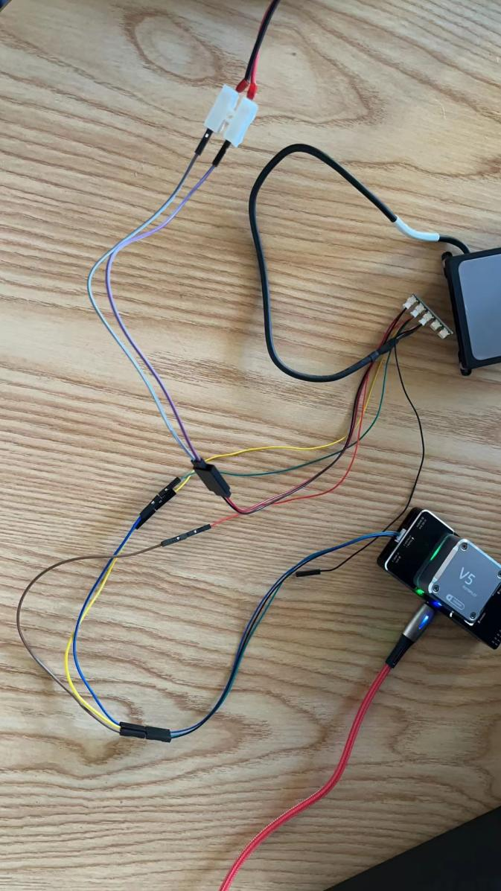
(Connection Example - for reference only)

Parameters Settings
Go to the Parameters page in the Settings and enter the keyword RDS02 in the search box to find SENS_RDS02_CFG, and select the communication serial port TELEM1,as shown below:
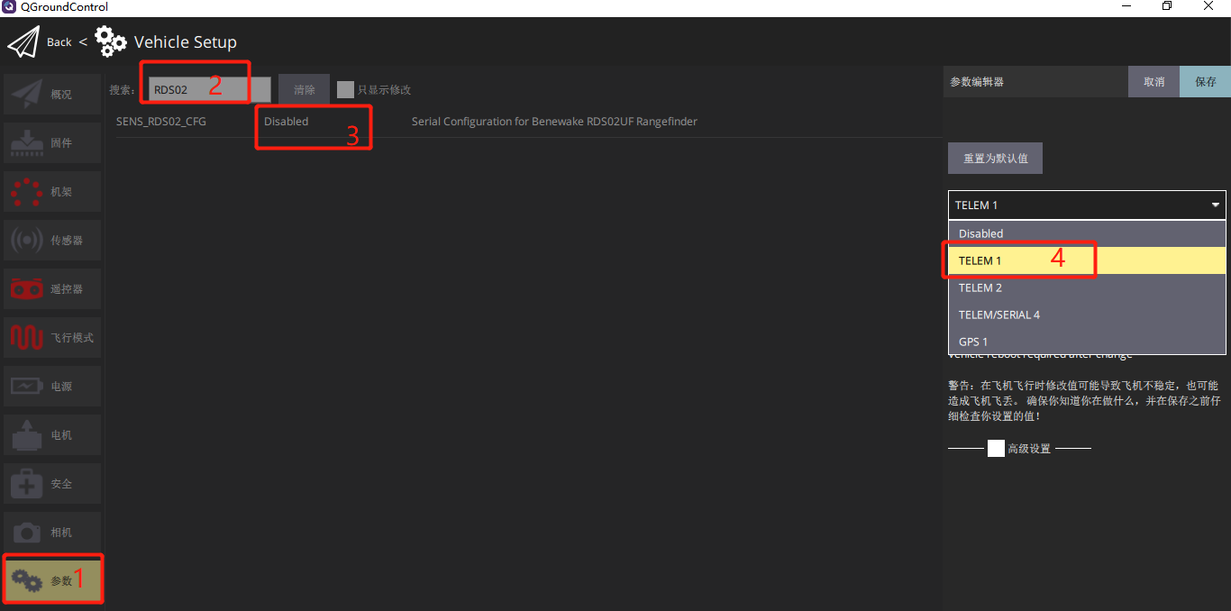
Parameter changes require a restart to take effect.After restarting your device, you should see something like the following:
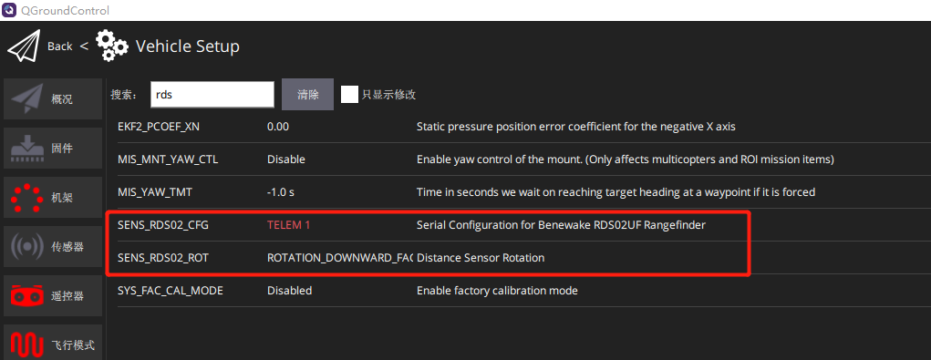
The parameters are described as follows:
SENS_RDS02_CFG //Select communication serial port
SENS_RDS02_ROT //Setting sensor orientation
Here, the serial port is set as TELEM1, and the direction is forward (obstacle avoidance), as shown below:(if the direction is downward ,it is altitude hold.)
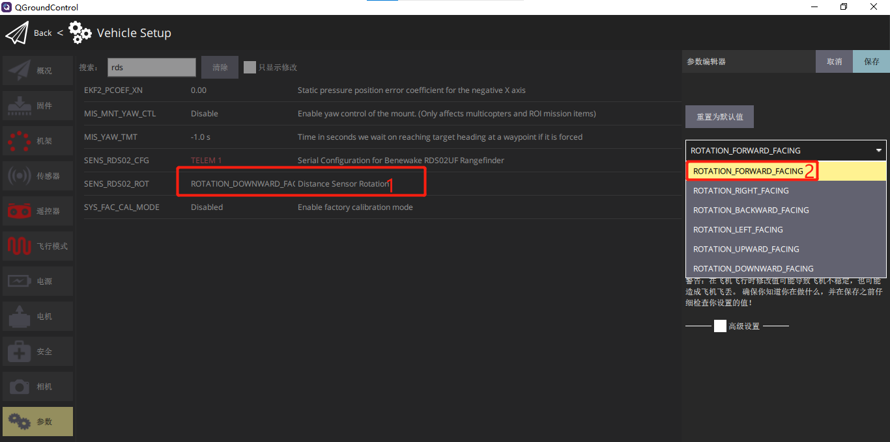
After restarting the device, the ranging value can be seen on the flight interface.

Data Test
Edit the data sheet below the QGC flight interface and add the range display value.
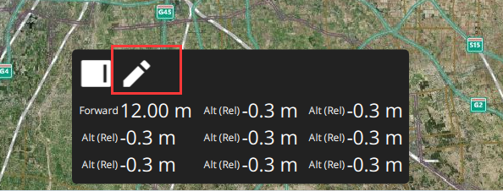
Click the pen flag to enter the edit mode, and click the value to modify the display content and modify the display of the ranging direction value.
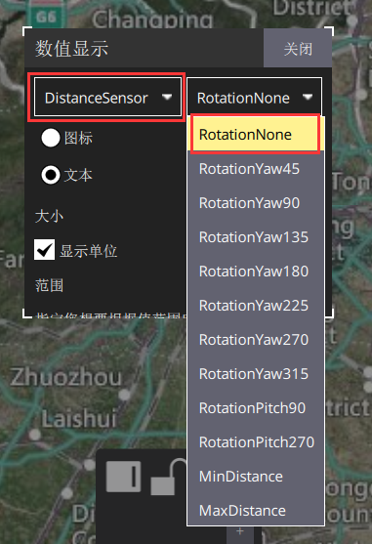
After modification, the display effect is as follows:
