

Configuring TF02-pro with IIC interface using Pixhawk (Px4 Firmware)



Introduction
This document provides first-time testers with instructions on how to test TF02-pro using Pixhawk (Px4 Firmware).
Applicable product model of this document ：TF02-pro-IIC(Confirm the hardware version and firmware version of the product before testing.)

Test Preparation
Preparing Tools | Number
PC with windows system | 1
4pin dubond wires | 1
TF02-pro-IIC | 1
Pixhawk（PX4 ） | 1
USB-UART converter | 1
QGroundControl
Px4 Firmware | px4_fmu-v3_main1.13.px4

2.1 Communication Protocol Switching
The default communication protocol of TF02-pro is UART serial communication. If you want to test the IIC communication protocol, you need to convert the communication protocol by sending instructions in UART communication mode to convert the communication interface protocol of TF02-pro to IIC. The specific operation steps are as follows:
- Connect TF02-pro and PC through USB-UART converter, as shown below:
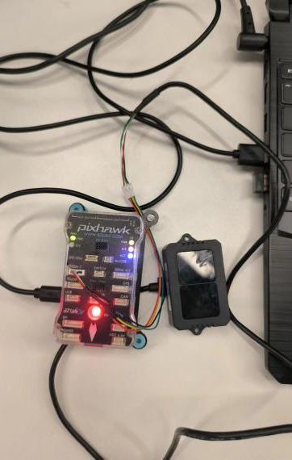
- Connect the USB-UART converter, check whether the COM driver of the computer recognizes the converter, and update the driver if the driver cannot be recognized.
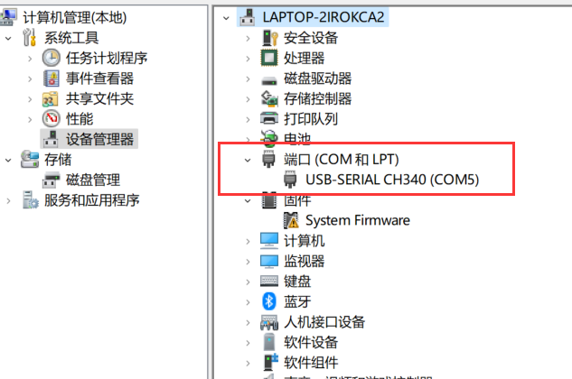
- Open the serial Assistant and select the correct port number, baud rate, etc .As shown below:
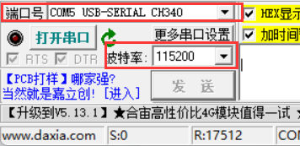
- Change the IIC communication protocol:
Send the communication interface setting instruction:5A 05 0A 01 00 and then send the saving command:5A 04 11 6F
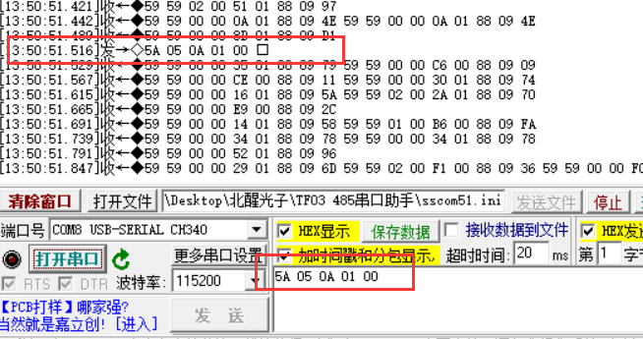
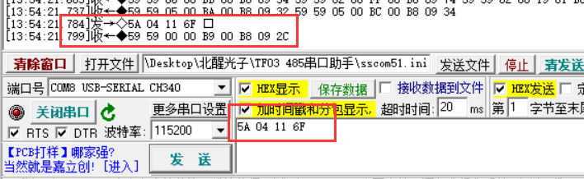
Power off and restart, and the device starts in IIC mode. It has been changed to IIC protocol and can be tested for IIC communication.

2.2 Slave Address Changing
Because multiple LiDAR sensors are involved, it is necessary to use the command to change the slave address (the default address of TF02-pro-IIC is 0x10, for example, change the slave address to 0x15) to send the command 5A 05 0B 15 00 in the input box ,as shown below:
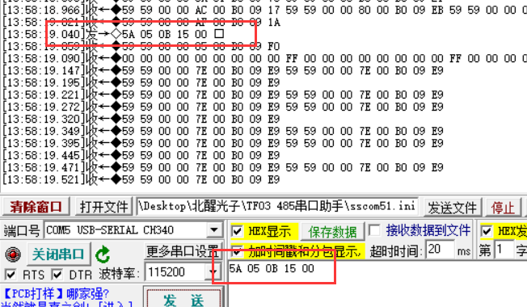
To save the changed slave address, please remember to send 5A 04 11 6F in the command box, as shown in the following figure:
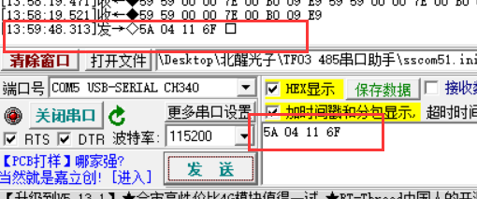
That is, changing the slave address is complete.
The following example was tested with six TFseries sensors, the addresses were set to 16 (0x10), 17(0x11), 18 (0x12), 19 (0x13), 20 (0x14), 21(0x15), and the rotation directions were front, right, back, up, down and left.

Px4 Firmware Burning
To upgrade firmware using QGC ground station, go to Vehicle Setup -> Firmware page of QGC
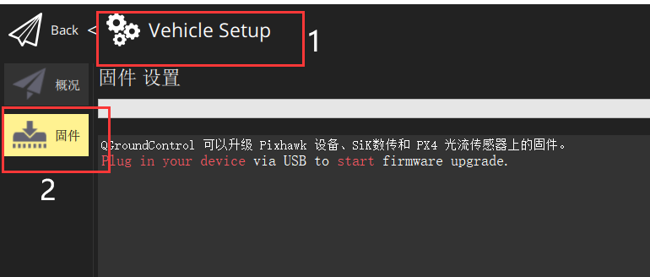
Use USB to connect to the flight control, select ‘PX4Pro’ in the pop-up firmware Settings, check ‘Advanced Settings’, and select ‘Custom firmware’.
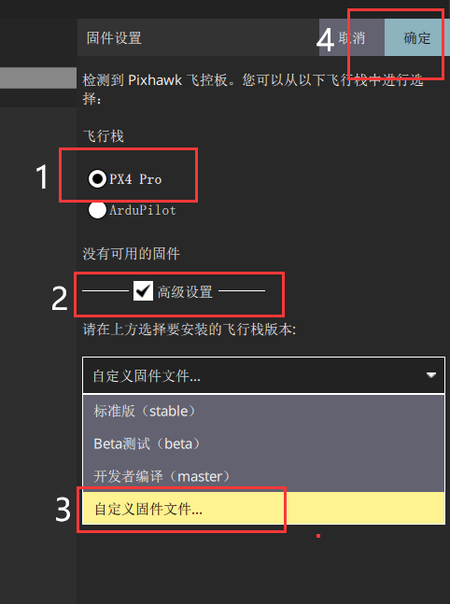
After loading our test firmware’px4_fmu-v3_main1.13.px4’, we enter the upgrade process.
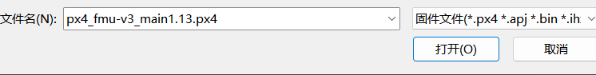
Wait for the upgrade progress bar to complete.
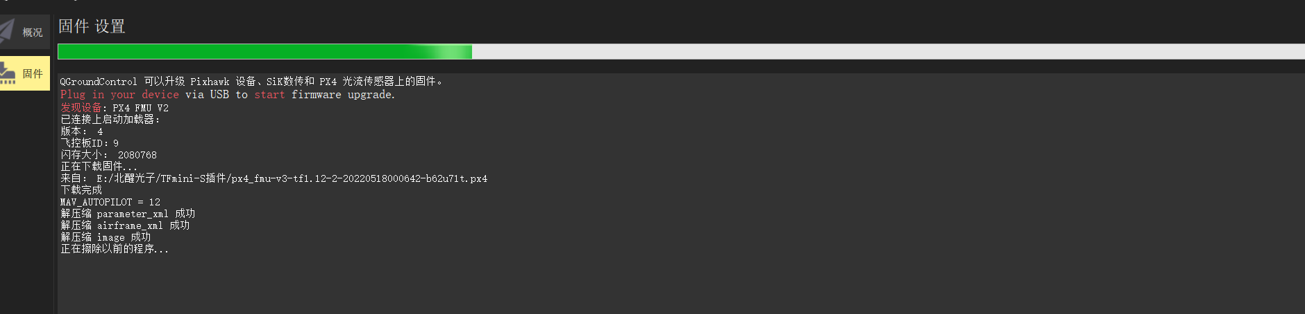

Hardware Configuration
The Pixhawk is connected to the LiDAR and the computer (note that the LiDAR ID matches the ID set by the computer), as shown below:
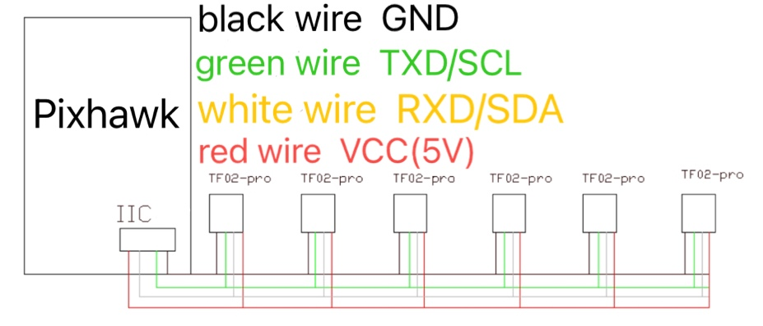
（schematic diagram）
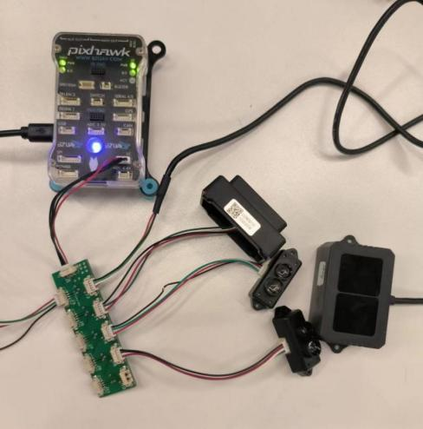
（Connection Example - for reference only）

Parameters Settings
Go to the Parameters page in the Settings and enter the keyword TF in the search box to find SENS_EN_TFI2C, and change the value to 6. Parameter changes require a restart to take effect.
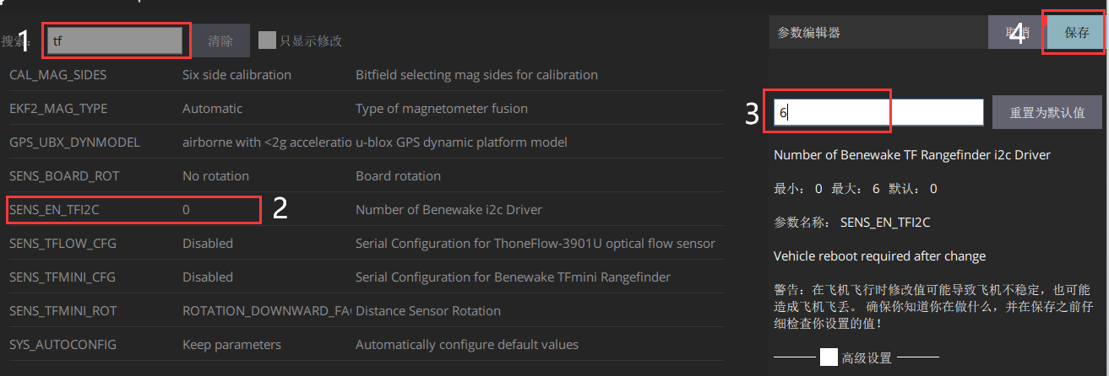
Restart the flight control and check the parameters again. There are 6 more SENS_TF_X_ADDR (slave address parameter of the x-th TF device), which is used to set the slave address. After setting, connect the LiDAR sensors to restart the flight control.
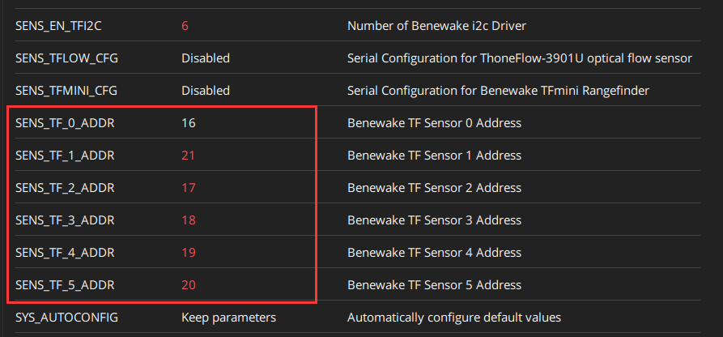

After the restart, set the test direction in turn.
This experiment set the direction in turn as follows:
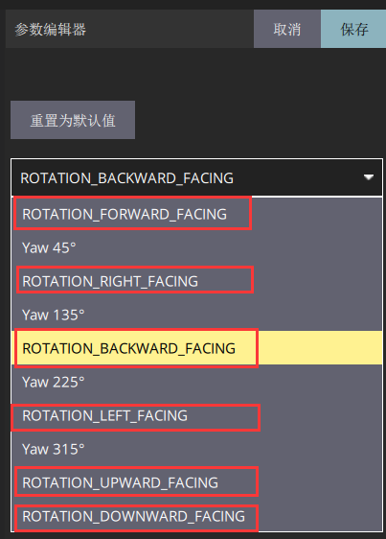
Here, we tested six TF modules with configured addresses, and set their rotation into six directions: front, right, back, left, up and down. After restarting the device, the ranging value can be seen on the flight interface.The parameters are described as follows:
SENS_TF_X_ADDR //The slave address of the x-th TF device
SENS_TF_X_ROT //The orientation settings for the x-th TF device
SENS_TF_X_MAXD //The maximum ranging setting for the x-th TF device in cm
SENS_TF_X_MIND //The minimum ranging setting for the x-th TF device in cm
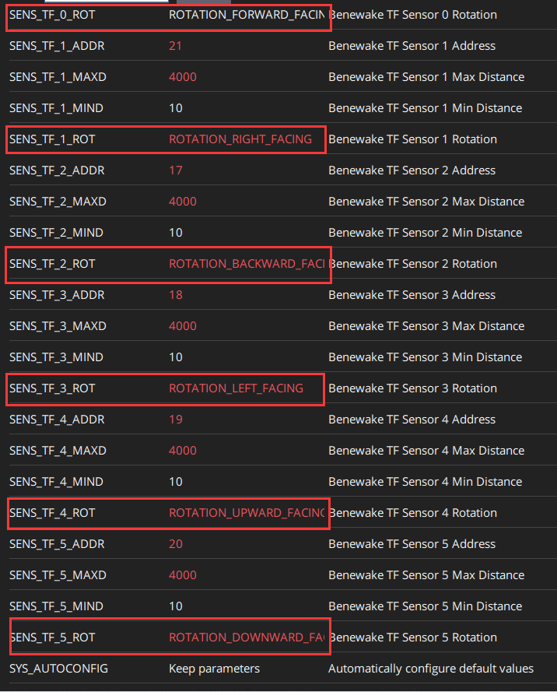
Above 16 (0x10) 17(0x11) 18 (0x12) 19 (0x13) 20 (0x14) and 21(0x15), the rotation directions are forward, right, backward, up, down, and left, respectively.

Data Test
Edit the data sheet below the QGC flight interface and add the range display value
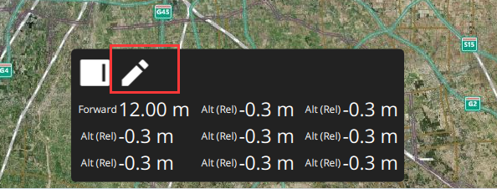
Click the pen flag to enter the edit mode, and click the value to modify the display content and modify the display of six ranging direction values.
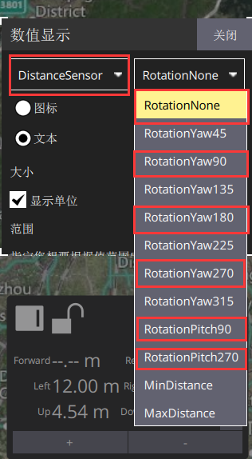1
After modification, the display effect is as follows:
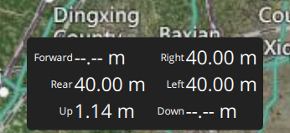
Note: After installing 4 LiDAR sensors, the data is stuck and refreshing is slow.
The solution can be: I2C pull-up resistor resistance and power supply voltage, transmission speed, bus capacitance (load factor) are related, at different rates of resistance generally have the following: 1.5K, 2.2K, 4.7K. 100KHz. The rate we use is 100Khz. The recommended pullup resistor is 4.7K.

